**5-2 Project One Submission**

Aaron Ciminelli

Information Technology Adjunct Faculty, SNHU

CS-255-T5581 System Analysis and Design 22EW5

**Matthew McHann, MBA, SEC+ , CySA+**

**June 05, 2022**

# CS 255 Business Requirements Document Template

Complete this template by replacing the bracketed text with the relevant information.

This template lays out all the different sections that you need to complete for Project One. Each section has guiding questions to prompt your thinking. These questions are meant to guide your initial responses to each area. You are encouraged to go beyond these questions using what you have learned in your readings. You will need to continually reference the interview transcript as you work to make sure that you are addressing your client's needs. There is no required length for the final document. Instead, the goal is to complete each section based on your client's needs.

**Tip:** You should respond in a bulleted list for each section. This will make your thoughts easier to reference when you move into the design phase for Project Two. One starter bullet has been provided for you in each section, but you will need to add more.

## System Components and Design

### Purpose

*What is the purpose of this project? Who is the client and what do they want their system to be able to do?*

* As part of our contract with DriverPass, Liam, the owner, and Ian, the IT officer, have entrusted our firm with developing a system that will make it easier for people to prepare for the DMV Test. As well as offering classes and practice tests, the system will also be able to schedule on-the-road training sessions. DriverPass is dedicated to ensuring that everyone has the tools necessary to pass their Drivers Test successfully on the first attempt.

### System Background

*What does DriverPass want the system to do? What is the problem they want to fix? What are the different components needed for this system?*

* Ian wants to provide a DriverPass system that provides people with tools to prepare for the Drivers Test at their local DMV. The goal of DriverPass is to change the trend and to create a trend of passing students rather than the now trend of failing students.
* With DriverPass, you will be able to:
  + Take and review Online Training Courses
  + Take Practice Tests
  + Conduct On-the-road training with an Instructor/Trainer
  + Receive and Review Instructor/Trainer feedback
* The DriverPass application should be accessible both online and offline. It will not be possible to perform certain functions offline, such as booking, rescheduling, or canceling on-the-road training. It will, however, be possible to take practice tests or review courseware when not connected to the Internet. DriverPass system should automatically upload and save any offline progress the user is making once the user establishes an online connection.
* There are limited packages and slots available for the DriverPass on-the-road training, so to avoid overbooking, the owner is asking to have a disable packages option.

### Objectives and Goals

*What should this system be able to do when it is completed? What measurable tasks need to be included in the system design to achieve this?*

* Using the DriverPass system, the end-user will be able to access online courses and practice tests. It is crucial that courses and tests are accessible while offline, but once the user reestablishes connectivity, the system should preserve all progress made while offline. With the DriverPass service, users will have the option of choosing between three different packages. Users of DriverPass are able to schedule, reschedule, or cancel their on-the-road training. Also, the system will allow users to enter their personal information securely, such as name, address, phone number, and credit card information for purchases.

## Requirements

### Nonfunctional Requirements

*In this section, you will detail the different nonfunctional requirements for the DriverPass system. You will need to think about the different things that the system needs to function properly.*

#### Performance Requirements

*What environments (web-based, application, etc.) does this system need to run in? How fast should the system run? How often should the system be updated?*

* For the DriverPass system to run effectively, the system should run in a cloud-based and web-based environment. For example, Amazon Web Services, Microsoft Azure, GitHub, or Google Cloud.
* The DriverPass system must run smoothly and quickly while simultaneously handling multiple users at once.
* The DriverPass system should be continuously monitored and updated when:
  + Bugs or flaws are found within the system
  + New Policies or rules are implemented
  + New features or benefits are discovered
  + New sample questions or guidelines are provided by the DMV

#### Platform Constraints

*What platforms (Windows, Unix, etc.) should the system run on? Does the back end require any tools, such as a database, to support this application?*

* The DriverPass system should run on multiple platforms
  + Windows
  + Android
  + Linus
  + macOS
  + iOS
* The DriverPass system will require the following databases and tools:
  + Account management software
  + Payment Processing software
  + Booking and scheduling Services
  + Learning Management Services (classes, study guides, practice tests)
  + Email and chat services to communicate with instructors and Admin
  + Support ticketing management services

#### Accuracy and Precision

*How will you distinguish between different users?* *Is the input case-sensitive? When should the system inform the Admin of a problem?*

* Each Instructor/Staff member will have a unique username:
  + The Username should be "Lastname.Firstname"
    - Not case sensitive
* Student/user will have a unique username:
  + The Username should be LastnameFirstInital## (last two digits of birth year)
    - Not case sensitive
* Passwords will:
  + Case sensitive
  + 8-14 Characters
  + Combination of Numbers Letters and Special character (!@#$%&)
  + At least Two UpperCase
  + Does not contain the Username
* Admin and/or IT will receive notification:
  + Security breaches
  + Bugs or flaws found
  + System failure/outage
  + New student enrollment
  + Scheduling capacity reached
  + IT support ticket request

#### Adaptability

*Can you make changes to the user (add/remove/modify) without changing code? How will the system adapt to platform updates? What type of access does the IT admin need?*

* Without changing the code, Admins, IT staff, instructors, and students can click on a designated link/source/button within the webpage(s).
* Admins will receive appropriate permissions to modify specific data as necessary.
* Admins can click on a designated link/source/button within the webpage(s) to :
  + Manually add and remove students
  + Modify, add, and remove student accounts
  + Manually Schedule Tests/on-the-road training
  + Manage student accounts and billing
  + Add or change Scheduling options or slots
* IT staff will receive appropriate permissions to modify and maintain the functionality of the system and make changes as necessary.
* IT can click on a designated link/source/button within the webpage(s) to :
  + Reset passwords
  + Modify, add, and remove student accounts
  + Manage student accounts and billing
  + Resolve IT related issues
* Instructors can click on a designated link/source/button within the webpage(s) to:
  + Add, change, and update courseware
  + Add, change, and update practice tests
  + Add, change, and update scheduling availability
  + Manage student grades
* Students/users can click on a designated link/source/button within the webpage(s) to :
  + Register for Username
  + Register for courses
  + Take practice tests
  + Request on-the-road practice tests
  + Manage account information
  + Change password
  + Make payments

#### Security

*What is required for the user to log in? How can you secure the connection or the data exchange between the client and the server? What should happen to the account if there is a "brute force" hacking attempt? What happens if the user forgets their password?*

* All users will use their unique Username and password to log in.
* Passwords will:
  + Case sensitive
  + 8-14 Characters
  + Combination of Numbers Letters and Special character (!@#$%&)
  + At least Two UpperCase
  + Does not contain the Username
* Each user will have appropriate permissions to change the system as needed.
  + Students can only make changes to their own account profile, view and take courses, communicate with instructors
  + Instructers can only modify courses, update student grades, communicate with other instructors and students
  + Adjust scheduling availability
* Admin and It can make changes to the system as needed
* Any Brute force attempts will automatically block the user's IP from accessing the system and immediately notify IT.
* If the user forgets their password:
  + User clicks link forgot password
    - Must answer security questions correctly
    - Or have the option to receive a code sent to their phone number on file
  + Contact IT support to manually reset the password after verifying information within the user's profile

### Functional Requirements

*Using the information from the scenario, think about the different functions the system needs to provide. Each of your bullets should start with "The system shall . . ." For example, one functional requirement might be, "The system shall validate user credentials when logging in."*

* The system shall validate the user's login credentials
* The system shall not log in if credentials are incorrect
* The system shall provide a link for users to reset their password
* The system shall notify Admin and IT of any brute force attack and block attackers from accessing the system
* The system shall verify that the user has access to courses or packages
* The system shall give access to purchased Packages and assign an instructor within the LMS
* The system shall allow students to take practice tests
* The system shall allow students to schedule on-the-road practice tests
* The system shall verify scheduling availability and assign students and instructors to the schedule
* The system shall send reminders and notifications of on-the-road practice tests
* The system shall allow users to download practice tests and courseware to their personal OS for offline use
* The system shall update information based on changes made by Admin or IT
* The system shall update courseware based on changes made by instructors or changes within the DMV requirements
* The system shall require users, Admin, and IT to verify credentials each time changes are made to the user profile or system.

### User Interface

*What are the needs of the interface? Who are the different users for this interface? What will each user need to be able to do through the interface? How will the user interact with the interface (mobile, browser, etc.)?*

* The interface will be designed to meet the needs of the user
* The user will access the interface through a web browser using their OS
  + Students will need permissions within the interface to:
    - View and take courses based on purchase packages
    - Take practice tests
    - View previous tests
    - Purchase additional courses or packages
    - Communicate with instructors or Admin via web-based chat browser or email
    - Have the ability to request time slots within the schedule based on availability
    - View instructor notes
  + Instructors will need permissions within the interface to:
    - Communicate with students through web-based chat, discussion boards, announcements, or email
    - Make notes for specific students
    - View and modify courses and practices test determined by DMV requirements
    - Adjust availability on the schedule
    - Make changes to student grades or progress
  + Admin staff will need permissions within the interface to:
    - Assign students to courses and instructors based on purchased packages
    - Make changes to the student profile
    - Manually purchase packages for students
    - Apply discounts to the student profile
    - Add, modify and delete users or students
    - Make necessary changes to the interface
  + IT staff will need permissions within the interface to:
    - Make changes to the user profile
    - Add and remove permissions to the user profile
    - Make changes based on policy, rules, or DMV requirements
    - Manually change user passwords
    - Add, change, modify, and delete user profiles
    - Make necessary changes to the system and interface

### Assumptions

*What things were not specifically addressed in your design above? What assumptions are you making in your design about the users or the technology they have?*

* The system is designed appropriately and has appropriate functionality
  + Courseware is available in a list view
  + User has an account view that lists their
    - Courseware accomplishments
    - Driver's permit photo or state ID
    - Address
    - Phone number
    - Payment information (if saved)
* All user's OS has the capability to access the system/webpage
* DriverPass has the appropriate funds to meet all requirements

### Limitations

*Any system you build will naturally have limitations. What limitations do you see in your system design? What limitations do you have as far as resources, time, budget, or technology?*

* Resources
  + Courseware developed and provided by subject matter experts and instructors
    - Instructors should be knowledgeable and experienced when it comes to training new drivers
    - Practice tests are provided by the DMV or previous DMV tests
    - All requirements are updated when necessary to comply with DMV requirements or when new policies or regulations are issued
* DriverPass has made no mention of any budget constraints. There is no way to know what kind of hosting service, cloud hosting service, and payment processing software a client can afford.
* The features of the functionality are limited to the 3rd party hosts that the client chooses that fit their budgets
* It is requested by the client that the project must be completed within a time period of 5 months
* The system is limited by the number of instructors who are available for the course
* Scheduling is limited to:
  + Available vehicles
  + Available seats or slots
  + Available instructors
  + Time and day (after hours, holidays, weekends)

### Gantt Chart

*Please include a screenshot of the GANTT chart that you created with Lucidchart. Be sure to check that it meets the plan described by the characters in the interview.*

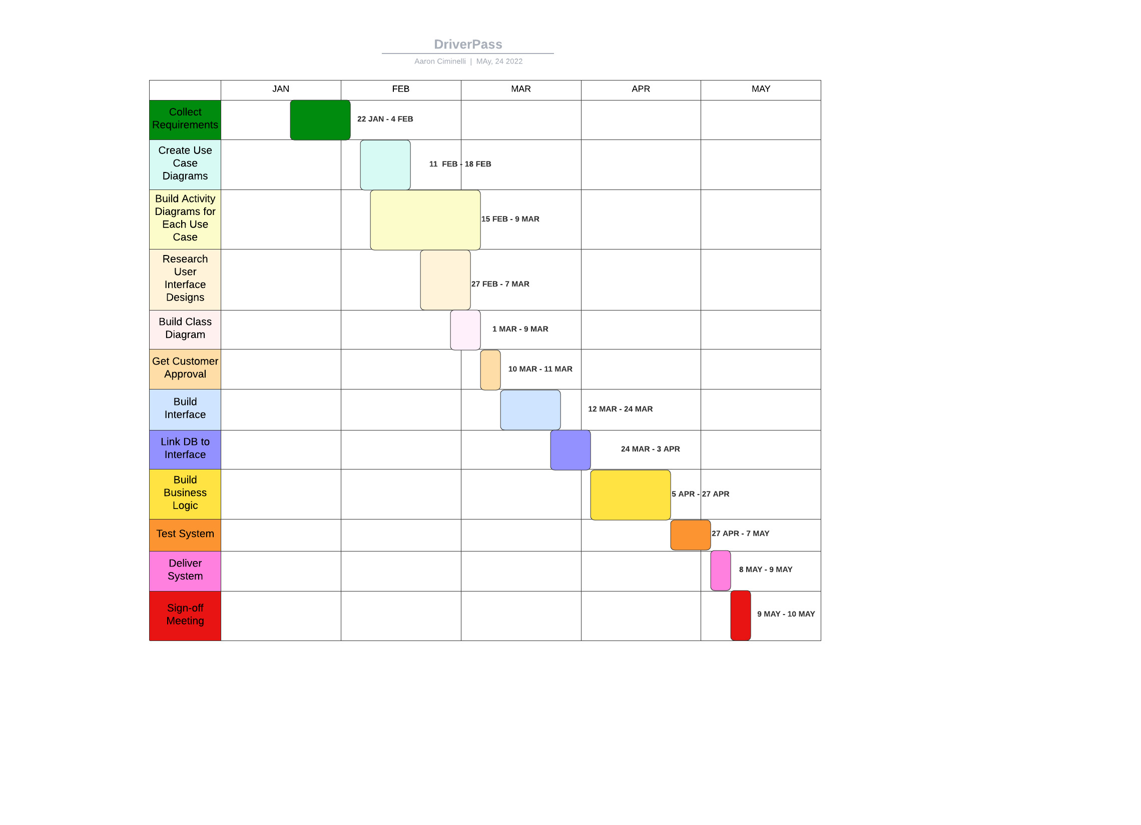

**References**

Valacich, J. S., & George, J. F. (2019). *Modern Systems Analysis and Design* (9th Edition). Pearson Education (US). https://mbsdirect.vitalsource.com/books/9780135172827